* **Como administrar usuários no banco de dados**

q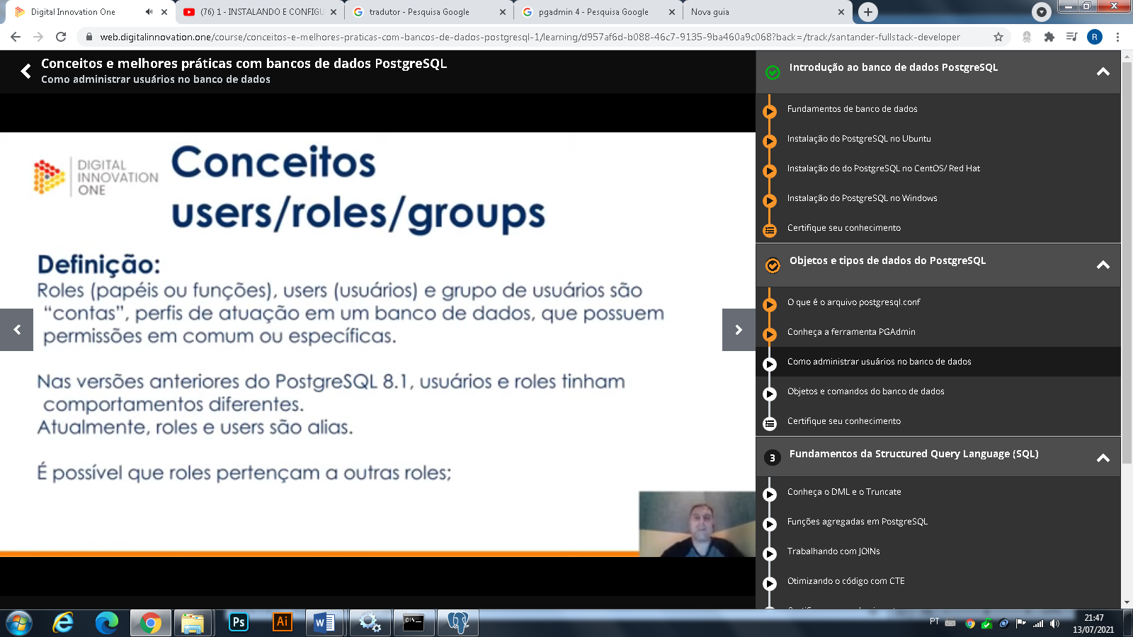

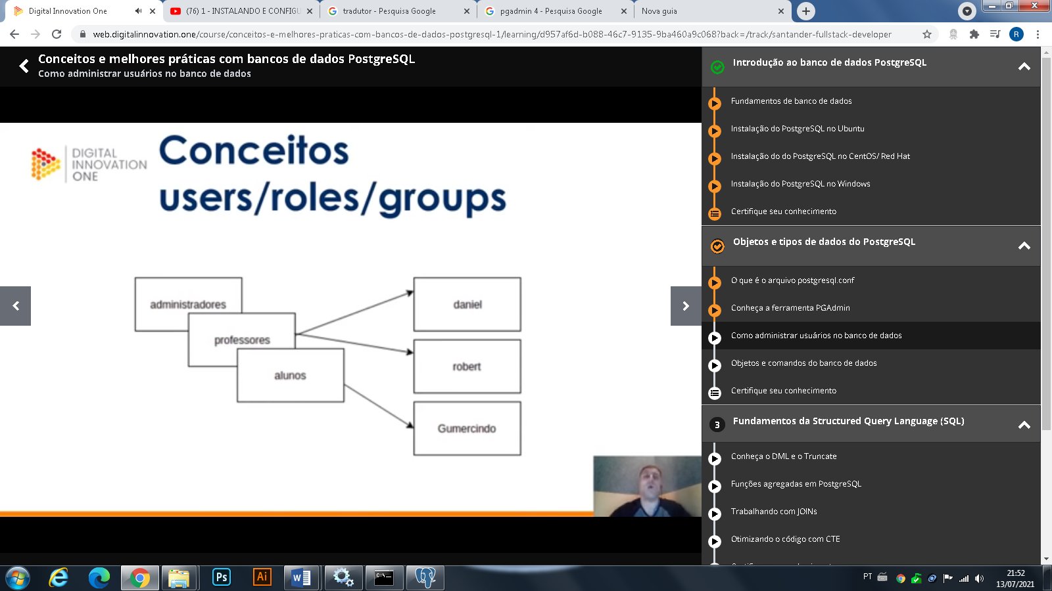

**Funcionamento de criação de roles/users/groups**

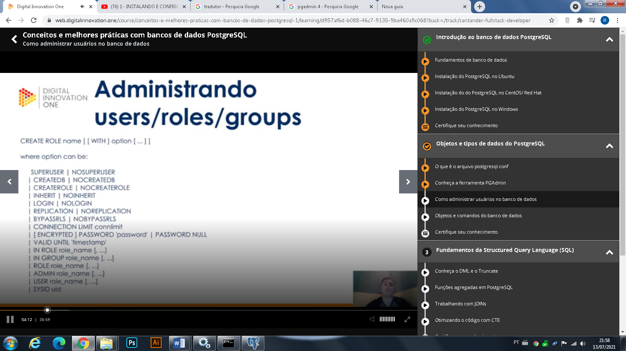

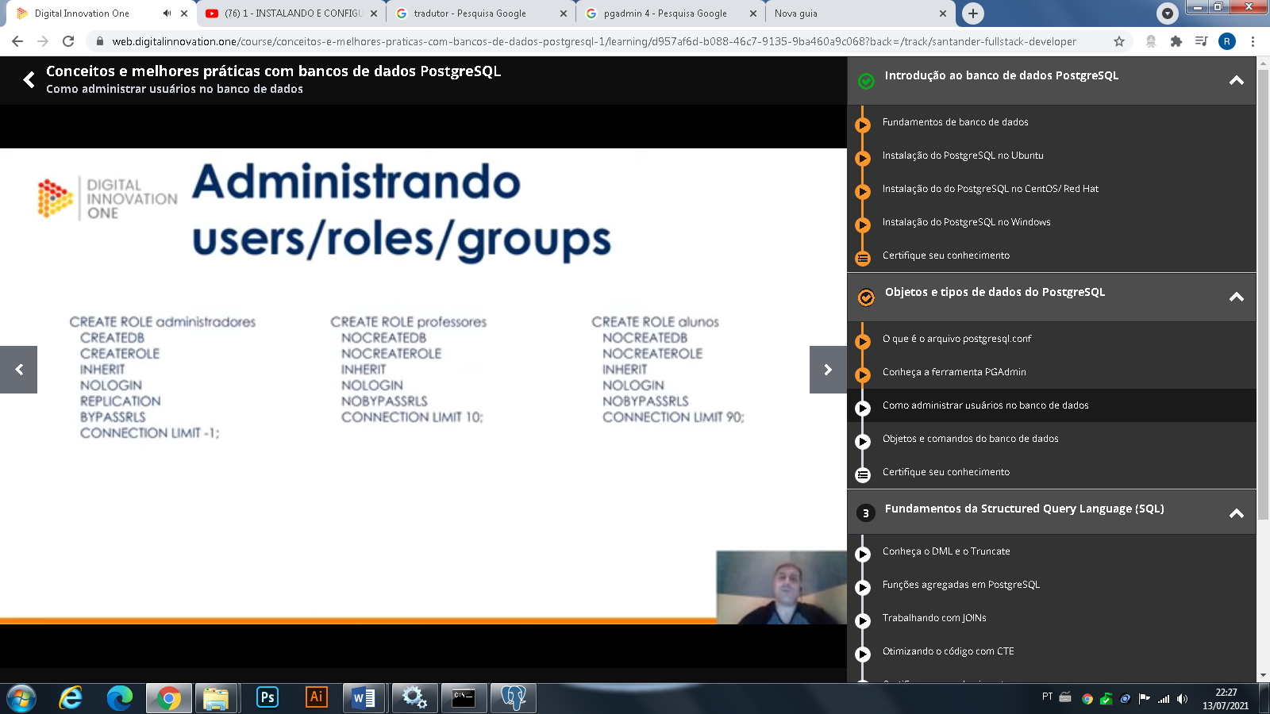

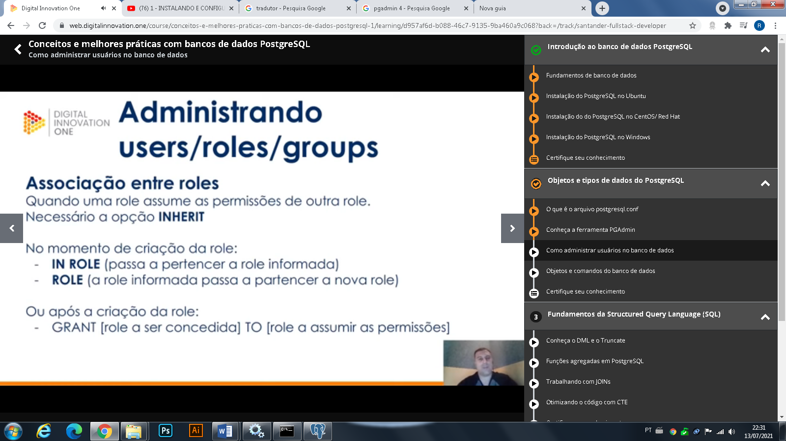

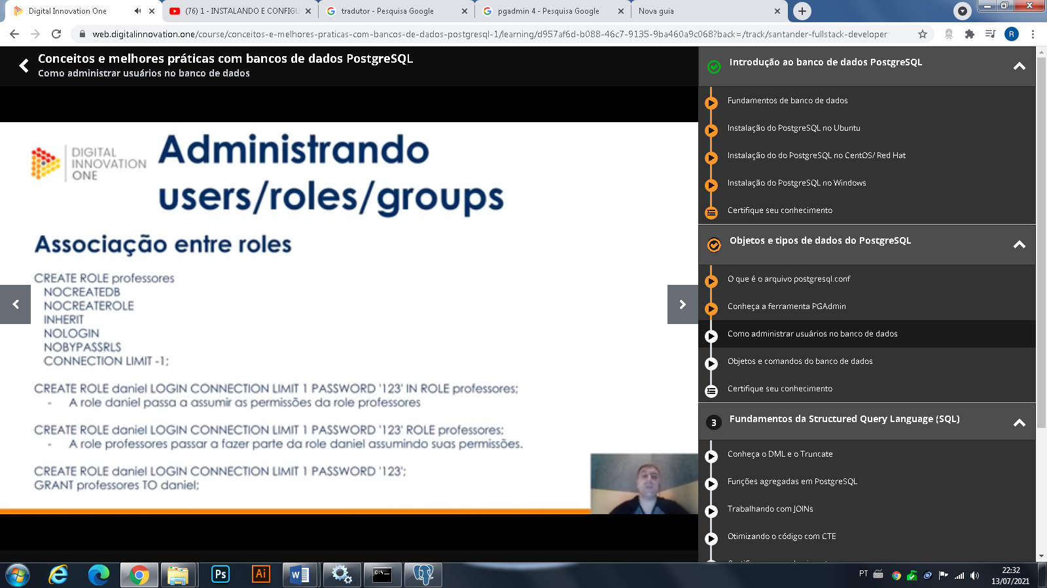

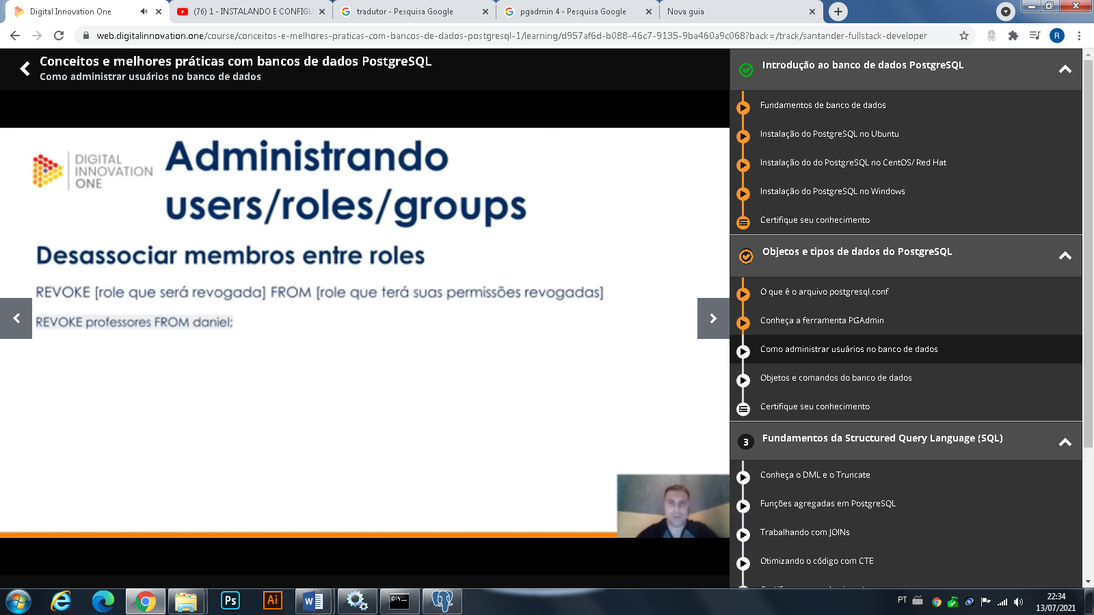

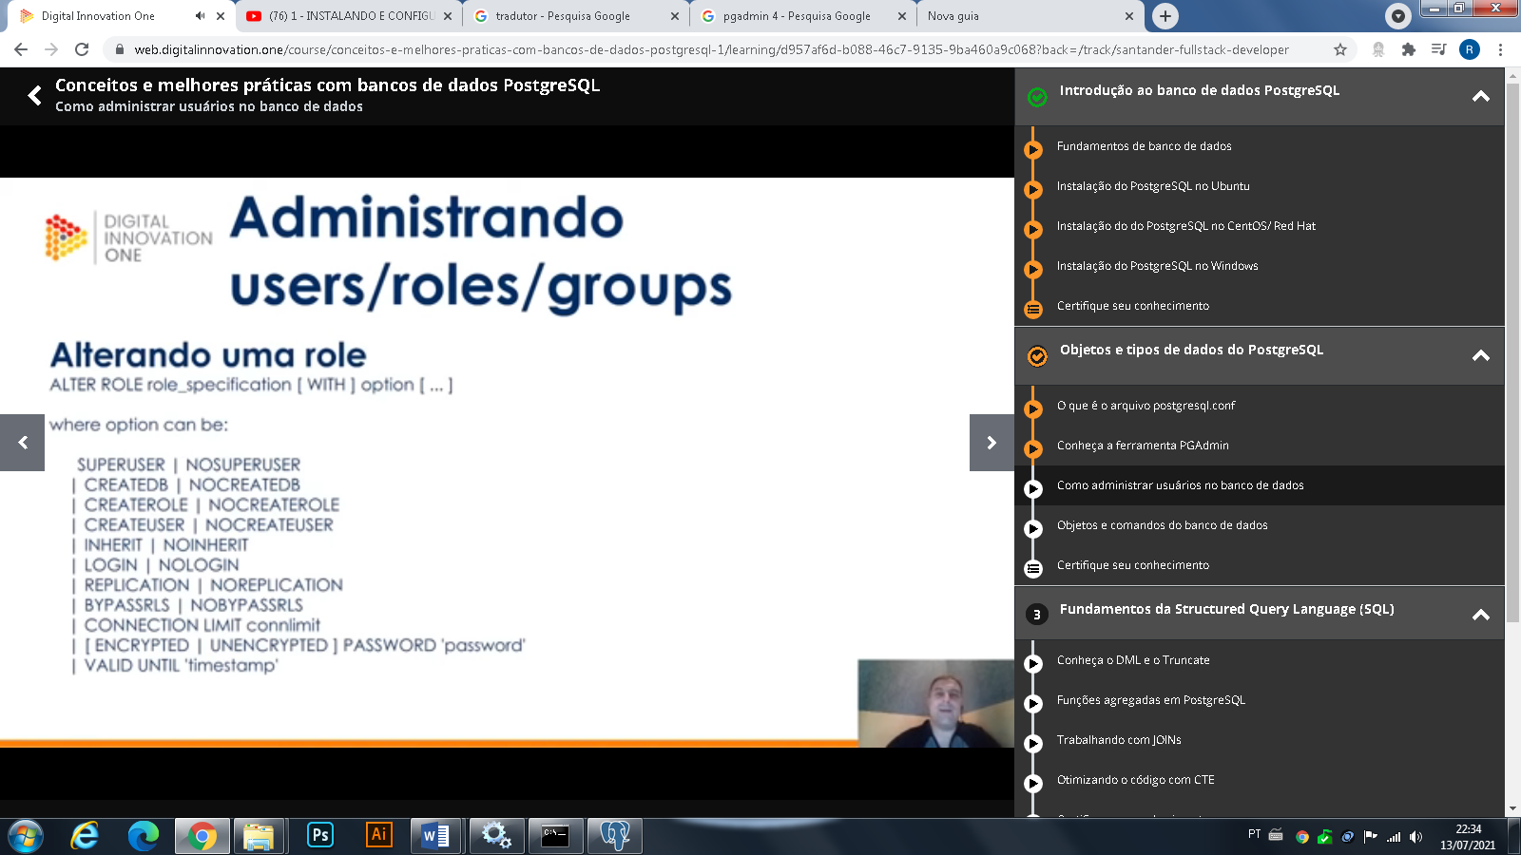

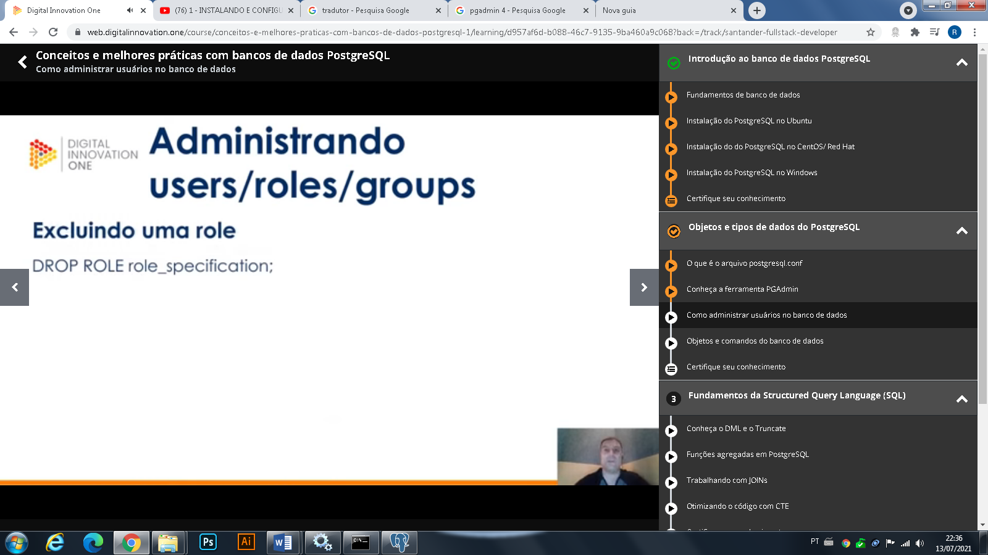

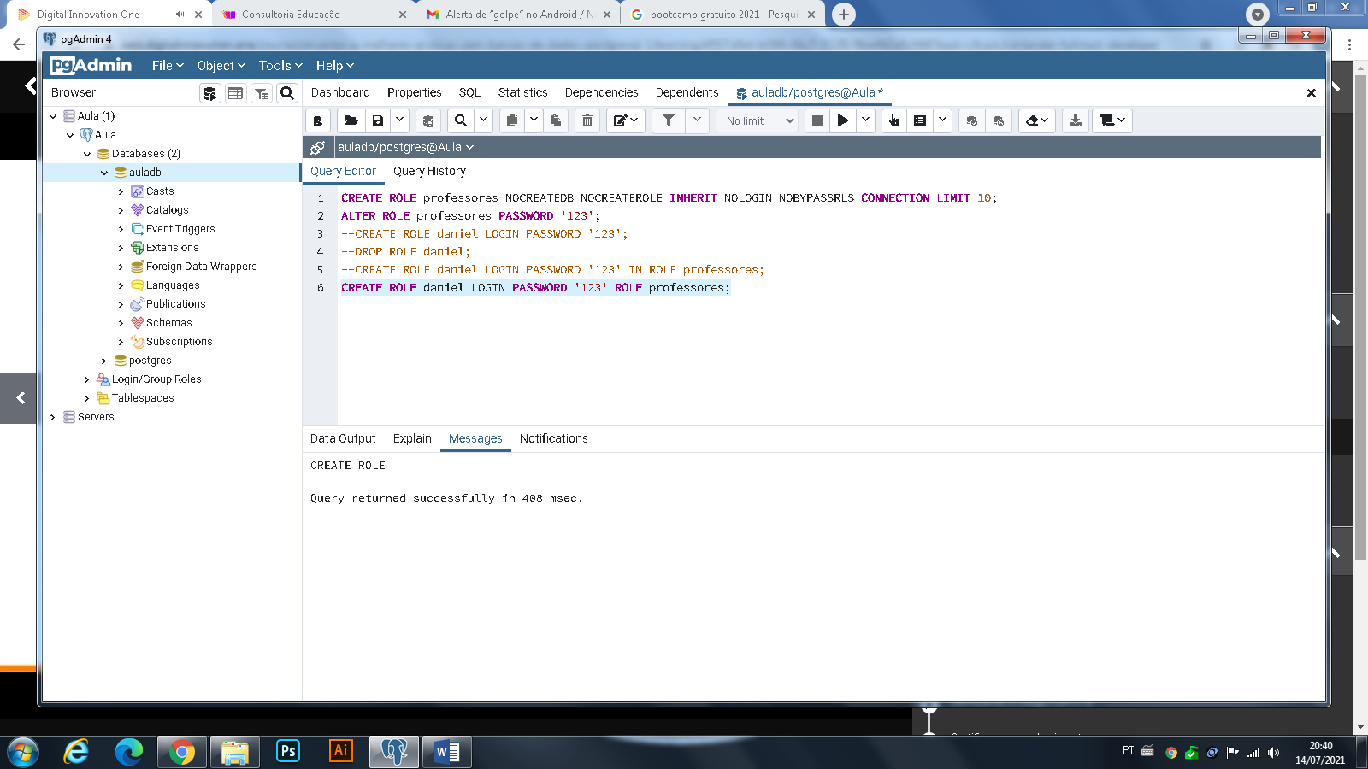

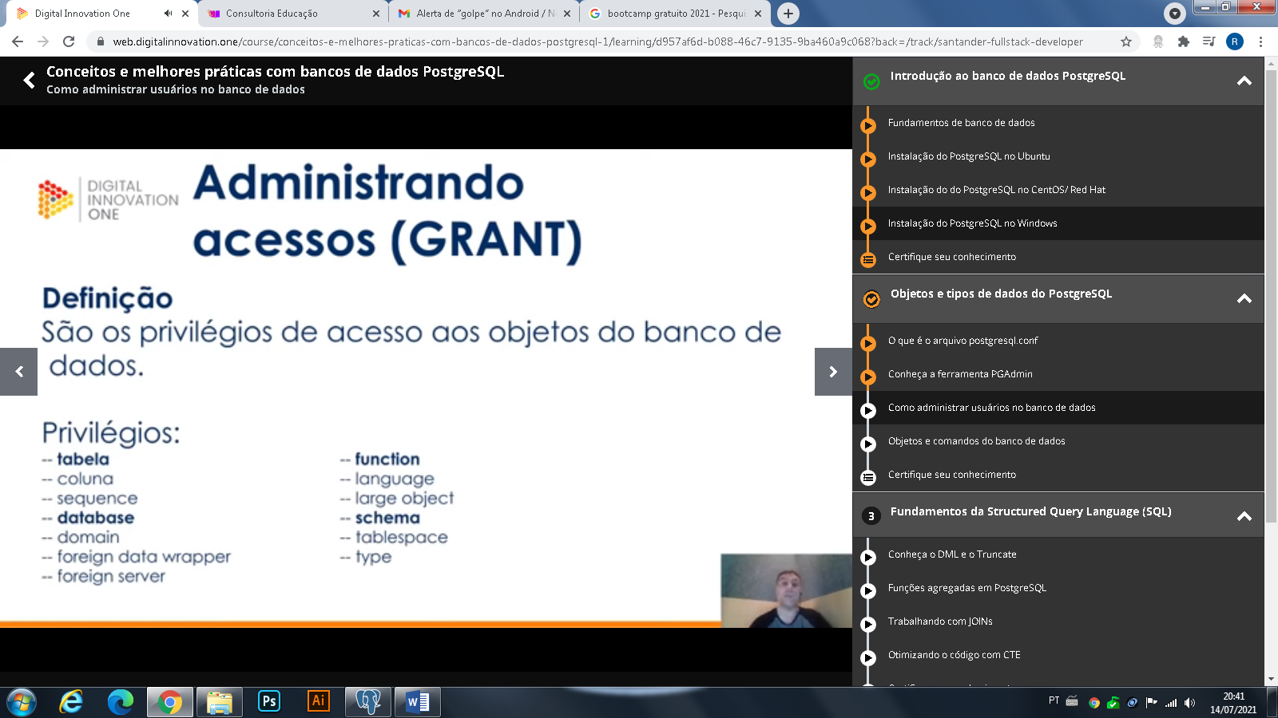

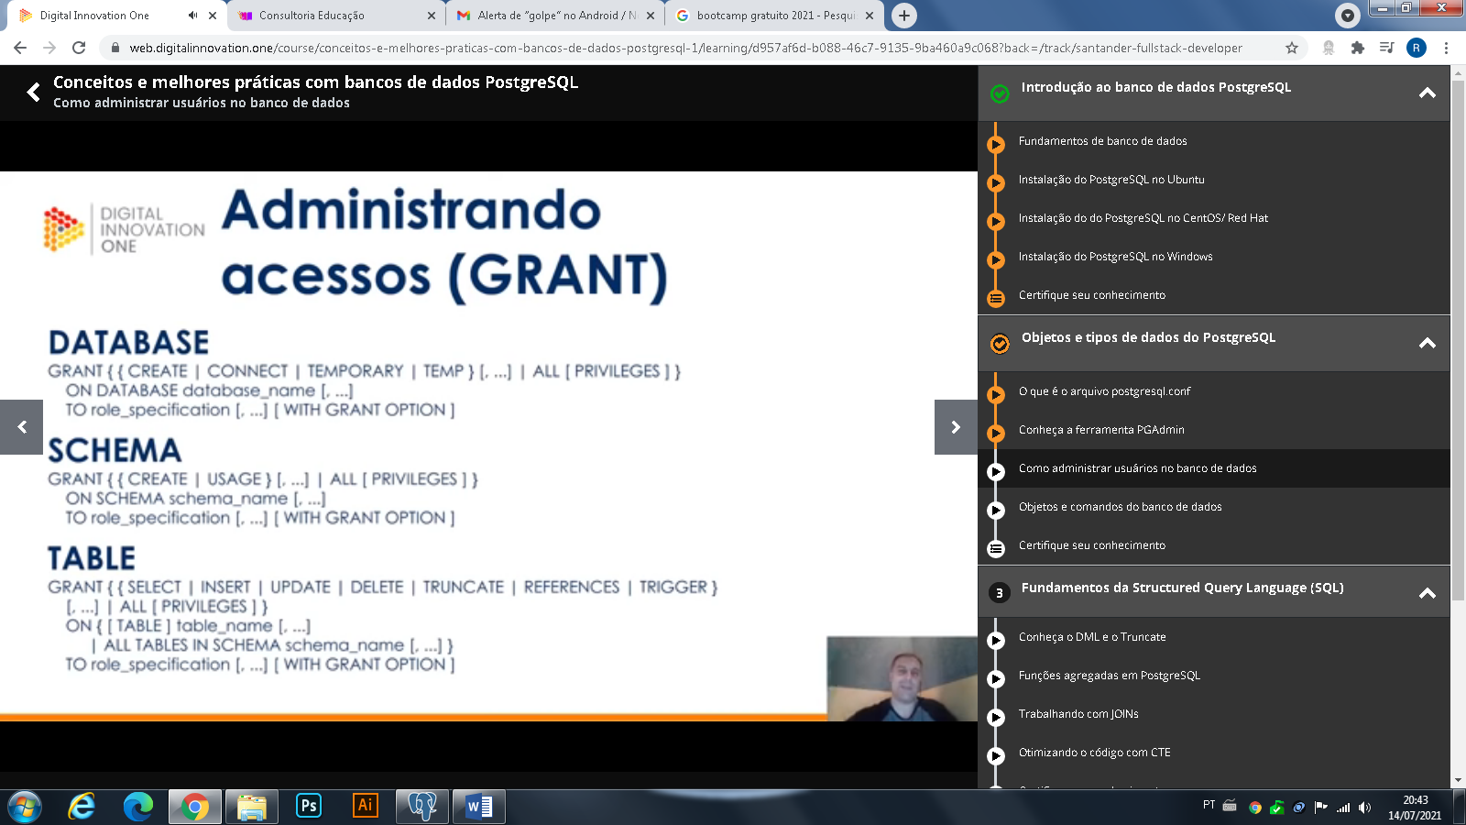

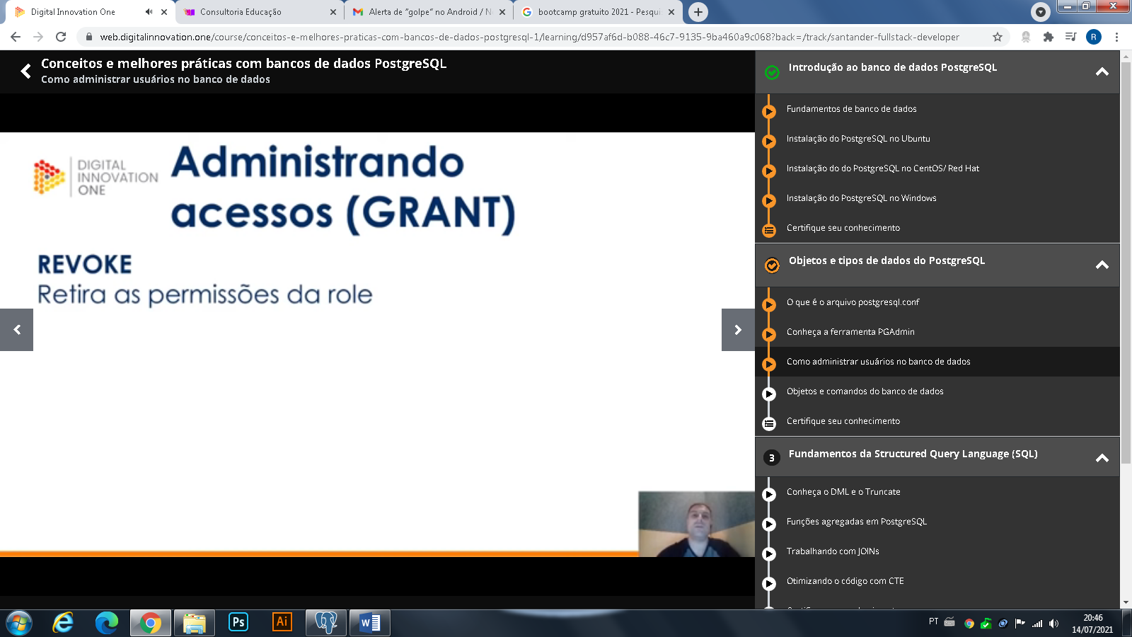

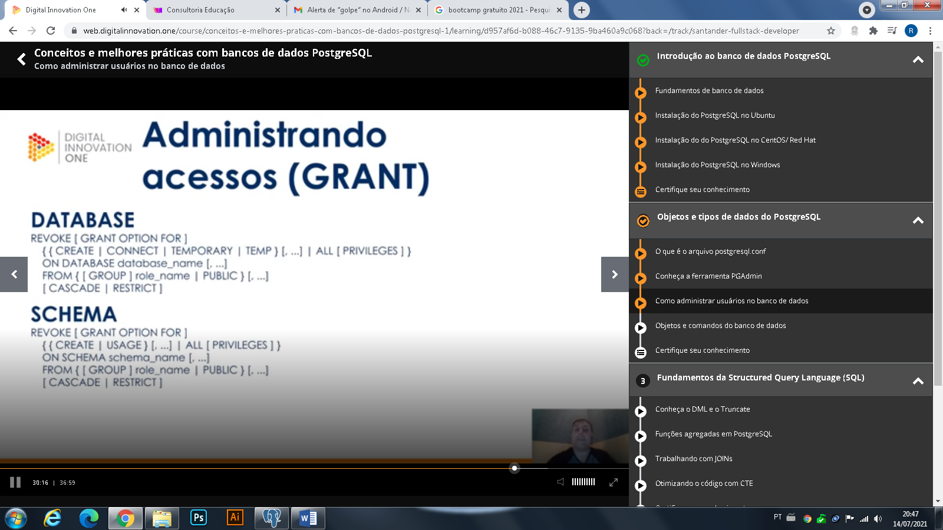

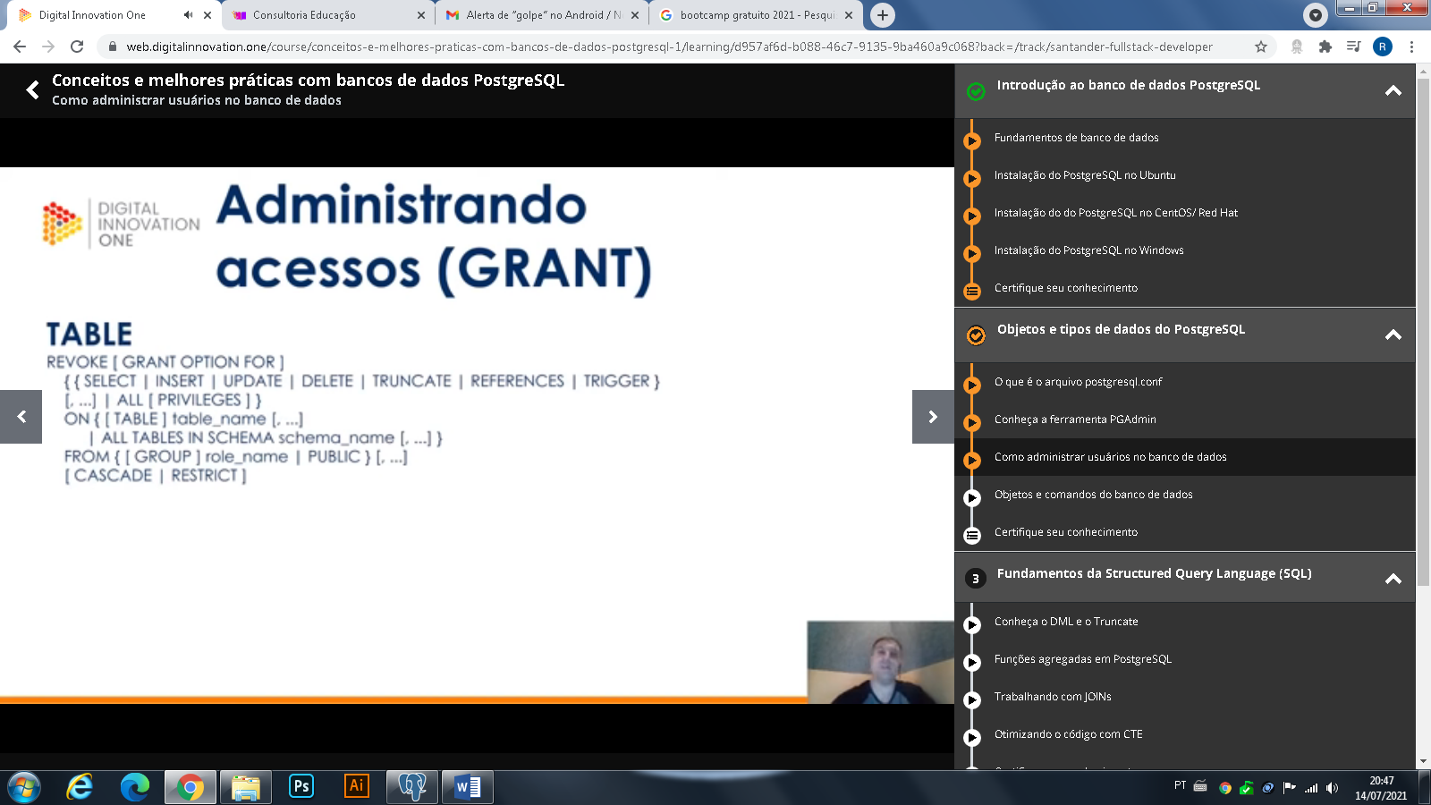

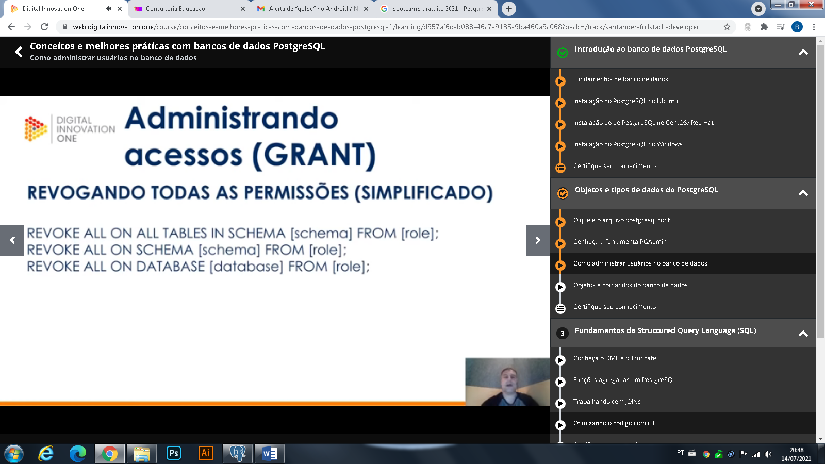

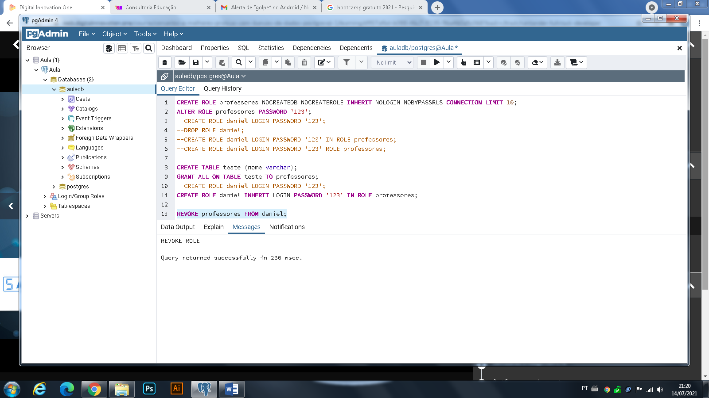

CREATE ROLE professores NOCREATEDB NOCREATEROLE INHERIT NOLOGIN NOBYPASSRLS CONNECTION LIMIT 10;

ALTER ROLE professores PASSWORD '123';

--CREATE ROLE daniel LOGIN PASSWORD '123';

--DROP ROLE daniel;

--CREATE ROLE daniel LOGIN PASSWORD '123' IN ROLE professores;

--CREATE ROLE daniel LOGIN PASSWORD '123' ROLE professores;

CREATE TABLE teste (nome varchar);

GRANT ALL ON TABLE teste TO professores;

--CREATE ROLE daniel LOGIN PASSWORD '123';

CREATE ROLE daniel INHERIT LOGIN PASSWORD '123' IN ROLE professores;

REVOKE professores FROM daniel;